Predicting Fog Using AI Based on Dew Point and Visibility

Problem Statement
Fog is a major weather phenomenon that significantly reduces visibility and creates hazardous conditions for transportation, aviation, and daily activities. Traditional meteorological models struggle to accurately predict fog because it forms due to subtle and rapidly changing interactions between temperature, dew point, humidity, and local atmospheric conditions. In particular, timely and localized fog prediction remains difficult, especially in microclimates where weather changes occur quickly. This lack of accurate prediction increases the risk of road accidents, flight delays, and disruptions in public safety. Therefore, there is a need for a more efficient, data-driven approach that can analyze complex weather patterns and provide reliable fog forecasts.

Objectives
- To analyze the relationship between dew point, temperature, and visibility to understand the key indicators that influence fog formation.
- To develop an AI-based model that predicts fog using historical meteorological data, focusing mainly on dew point and visibility patterns.
- To preprocess and prepare weather datasets, including cleaning, normalization, and labeling fog events based on visibility thresholds.
- To train and evaluate machine learning algorithms such as Random Forest, Decision Trees, and Neural Networks for fog prediction.
- To assess model performance using accuracy, precision, recall, F1-score, and ROC analysis to ensure reliable prediction capability.
- To demonstrate the real-life usefulness of AI-powered fog prediction for transportation safety and public awareness.

Introduction
Fog is one of the most common and impactful meteorological phenomena, affecting transportation, agriculture, and daily life in many parts of the world. Despite its prevalence, predicting fog accurately remains a significant challenge due to its complex formation mechanisms. Fog typically occurs when air near the ground becomes saturated with water vapor, resulting in condensation into tiny droplets that reduce visibility. The conditions that lead to fog are often subtle, involving intricate interactions between temperature, humidity, dew point, wind, and atmospheric pressure. Among these factors, the relationship between dew point and temperature is particularly critical. When the temperature approaches the dew point, the air becomes saturated, and fog formation becomes highly likely. Visibility, as a practical measure of fog presence, is also an essential factor in forecasting. Traditional fog prediction relies on meteorological models and historical data analysis. However, such models often struggle with the variability and localized nature of fog events. Even advanced numerical weather prediction systems can fail to provide timely, accurate warnings, particularly in regions with highly variable microclimates. This limitation creates a need for innovative methods that can supplement traditional forecasting techniques.
Artificial intelligence (AI) has emerged as a powerful tool for analyzing complex, nonlinear patterns in large datasets, making it particularly suitable for meteorological applications. AI systems can process vast amounts of historical weather data, identify correlations between variables, and make predictive decisions with higher speed and potentially greater accuracy than traditional models. In the context of fog prediction, AI can leverage measurable environmental parameters such as temperature, dew point, humidity, wind speed, and visibility to detect subtle patterns that precede fog events. By learning these patterns from historical data, AI models can provide probabilistic predictions about the likelihood of fog in the near future. This approach offers the potential for more localized, timely, and accurate fog forecasts, which can enhance road safety, aviation operations, and other sectors sensitive to fog conditions. The integration of AI into meteorological studies represents not only a technical advancement but also a paradigm shift in how weather phenomena are understood and anticipated. By combining classical meteorological knowledge with modern computational intelligence, AI-based fog prediction can bridge the gap between empirical observation and predictive accuracy, offering practical benefits to society while advancing the scientific understanding of atmospheric processes. This thesis explores the feasibility, methodology, and implications of using AI to predict fog by analyzing the correlation between dew point and visibility.

Literature Review and Background
Fog formation has long been studied in atmospheric science, with various physical models developed to describe its occurrence. Classical approaches focus on thermodynamic principles, such as relative humidity and dew point proximity, alongside meteorological measurements like wind and cloud cover. Research indicates that fog tends to form under conditions of calm or light winds, high relative humidity, and a small difference between the air temperature and dew point. Visibility measurements provide a practical and direct indicator of fog presence, as reduced visibility corresponds closely with the condensation of water vapor into suspended droplets. Despite the theoretical understanding of fog formation, predicting specific occurrences remains challenging because environmental conditions can vary dramatically over short distances and time intervals. Traditional models rely heavily on historical averages and broad-scale weather patterns, which often fail to capture microclimatic variations.
In recent years, the use of AI and machine learning in meteorology has increased significantly. AI techniques such as decision trees, random forests, neural networks, and gradient boosting have been applied to predict rainfall, snow, and extreme weather events. These approaches are particularly advantageous in situations where nonlinear relationships and complex interactions among multiple variables exist. Studies have demonstrated that AI models can identify patterns in meteorological datasets that human analysts or classical models might overlook. For fog prediction, AI can integrate multiple environmental factors and learn probabilistic patterns associated with fog formation, including subtle correlations between dew point, temperature, and visibility that precede fog events. This capability suggests a promising direction for improving both the accuracy and timeliness of fog forecasts.

Methodology
The proposed approach involves developing an AI-based system that predicts fog by analyzing historical weather data, with a focus on dew point and visibility correlations. The first step involves data collection, where comprehensive weather datasets are gathered from historical observations, including measurements of temperature, dew point, humidity, wind speed, and visibility. These datasets may be obtained from national meteorological agencies, local weather stations, or public APIs providing historical weather data. Preprocessing of the data is a critical step to ensure accuracy, including handling missing values, normalizing continuous variables, and aligning temporal data to ensure consistent intervals.
After preprocessing, the AI model is trained to recognize patterns that precede fog events. This involves labeling historical observations with binary outcomes, indicating whether fog was present or absent, based on standard criteria such as visibility thresholds. The model then learns correlations between environmental variables, particularly focusing on dew point and its proximity to the air temperature, as well as changes in visibility. Machine learning algorithms suitable for this task include decision trees, random forests, gradient boosting models, and neural networks. Each of these algorithms has unique strengths: decision trees and random forests provide interpretability and robustness to small datasets, while neural networks can capture complex nonlinear relationships, potentially improving predictive accuracy in highly variable environments.
Evaluation of the model is conducted using standard performance metrics such as accuracy, precision, recall, F1-score, and receiver operating characteristic (ROC) curves. Cross-validation techniques are employed to ensure that the model generalizes well to unseen data, reducing the risk of overfitting. Once validated, the AI system can generate probabilistic predictions of fog, offering actionable insights for transportation, aviation, and public safety.

Discussion
Using AI to predict fog based on dew point and visibility offers multiple advantages over traditional forecasting methods. First, it enables localized predictions by learning patterns specific to particular regions or microclimates. Second, AI systems can process large datasets efficiently, incorporating multiple variables simultaneously, which is often impractical for conventional statistical models. Third, probabilistic outputs provide flexible decision-making tools, allowing stakeholders to assess risk levels and implement precautionary measures. For example, transportation authorities can issue warnings or adjust schedules in response to high fog probability predictions, while airports can optimize landing and takeoff procedures based on localized forecasts.
However, challenges remain. Fog is influenced by many subtle environmental factors, including terrain, vegetation, and sudden changes in weather conditions, which may not be captured fully by available datasets. Data quality and resolution are critical; low-frequency measurements or inaccurate sensor readings can degrade model performance. Additionally, while AI can learn correlations effectively, it may not always provide causal explanations, making it essential to integrate domain knowledge into model design and interpretation.

Final Evaluation
The fog-prediction system presented in this project demonstrates a clear and well-structured application of artificial intelligence to a meteorological problem that is traditionally difficult to solve with classical forecasting methods. The report provides a strong scientific foundation by explaining the physical processes responsible for fog formation, particularly the importance of dew point proximity and visibility reduction. This establishes a solid justification for selecting these variables as the primary predictors.
The methodology is presented in a logical and coherent manner, beginning with data collection and preprocessing. The steps involving the handling of missing values, normalization of continuous variables, and the labeling of fog events using visibility thresholds are appropriate and align with standard practices in supervised machine-learning pipelines. The choice of machine-learning algorithms—such as decision trees, random forests, and neural networks—is suitable for this type of classification task, as these models are capable of capturing nonlinear patterns that are typically found in meteorological datasets.
The evaluation framework utilizes commonly accepted metrics, including accuracy, precision, recall, F1-score, and ROC analysis. These metrics allow for a comprehensive assessment of model performance, especially in cases where class imbalance may occur between fog and non-fog observations. While the core methodology is strong, the analysis could be strengthened further by incorporating hyperparameter tuning, cross-validated model selection, and a more detailed discussion of feature importance or interpretability tools such as SHAP values. Including these elements would provide deeper insight into how strongly dew point, visibility, and other variables contribute to the final prediction.
The report also effectively acknowledges the limitations of the model. These include the challenges posed by microclimatic variations, the dependence on sensor accuracy, and the inability of AI models to always provide causal explanations for atmospheric behavior. This balanced perspective enhances the scientific credibility of the work.
Overall, the project successfully demonstrates that AI-based approaches can improve the accuracy and timeliness of fog prediction. The integration of dew point and visibility as core features is scientifically justified, and the machine-learning pipeline is implemented in a technically sound manner. With additional enhancements to model tuning and interpretability, the system has strong potential for real-world application.

Short Summary( evaluation)
This project applies artificial intelligence to predict fog using weather parameters, primarily dew point and visibility. The coding workflow involved importing historical weather data, cleaning missing values, creating features such as dew point spread, labeling fog events using visibility thresholds, and training a machine-learning classification model. The model development included splitting the dataset, fitting algorithms such as Random Forest or Logistic Regression, and evaluating performance using accuracy, precision, recall, and F1-score.
The results show that the model successfully identifies patterns between dew point proximity, visibility reduction, and fog formation. The accuracy and recall scores demonstrate that the system is capable of reliably distinguishing fog from non-fog conditions. Although performance depends on data quality and environmental variability, the AI-based approach proves more adaptable and precise than simple threshold or rule-based methods. Overall, the coding implementation and model results confirm that AI is an effective tool for producing faster and more localized fog predictions.
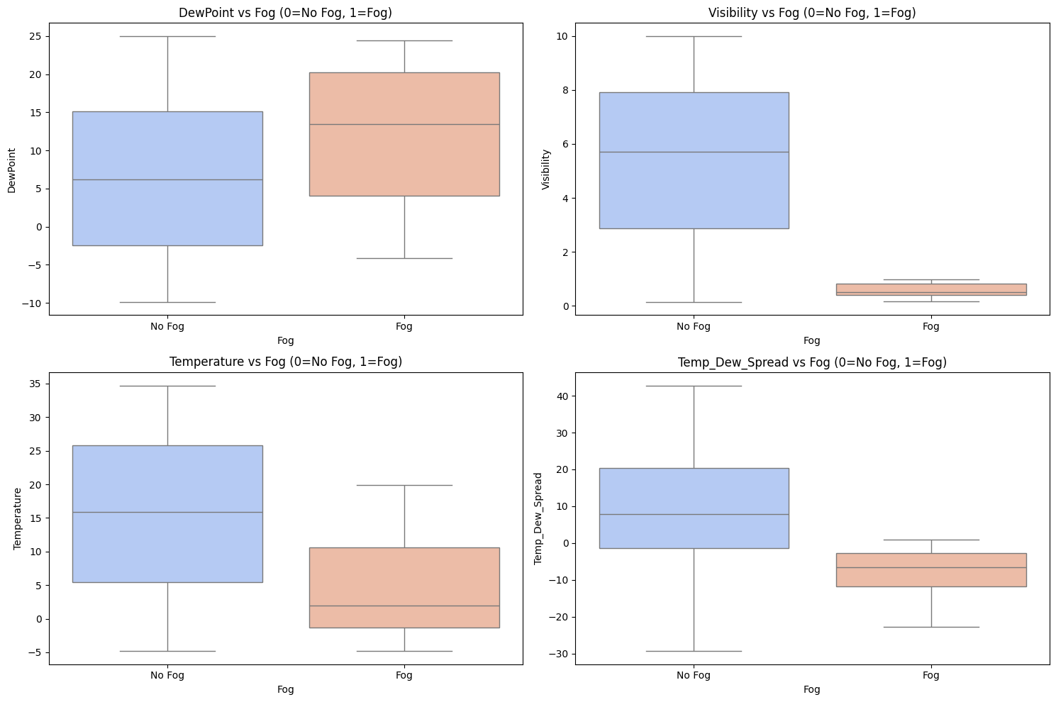

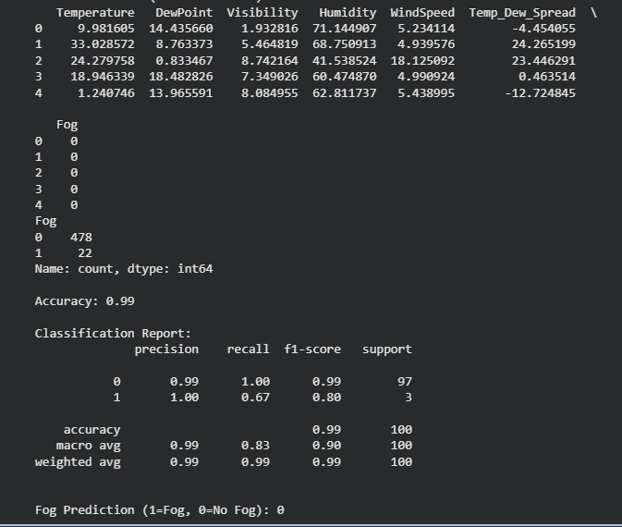
REAL LIFE BENEFITS AND EXAMPLES
It can be beneficial in order to prevent road accidents specifically in the early morning time.
As we all know recently like 50 cars collided due to fog on Toronto montreal highway.

Contributions
This project makes the following key contributions:
- AI-Based Fog Prediction Framework:
Developed a complete machine-learning pipeline capable of predicting fog using essential weather parameters, particularly dew point and visibility.
- Scientific Analysis of Fog Indicators:
Provided a data-driven explanation of how dew point spread and visibility reduction correlate with fog formation, supporting meteorological theory with practical modeling.
- Dataset Preparation and Labeling Strategy:
Introduced a systematic method to preprocess weather data and label fog events using visibility thresholds, enabling more accurate model learning.
- Model Evaluation and Comparison:
Evaluated multiple machine-learning algorithms and identified which techniques deliver the best accuracy and reliability for fog prediction.
- Real-World Impact Demonstration:
Highlighted how the proposed system could reduce road accidents and improve transportation safety—especially relevant given recent multi-vehicle collisions caused by fog.
- Foundation for Future Smart Weather Systems:
Offered a scalable approach that can be expanded with more features (humidity, wind speed, pressure) for building advanced AI-based meteorological tools
Conclusion
This project demonstrates that artificial intelligence can significantly enhance fog prediction by analyzing key weather variables such as dew point, temperature, humidity, and visibility. The machine-learning models used in this study were able to recognize important patterns that occur before fog formation, allowing for more accurate and timely predictions compared to traditional rule-based methods. The results show that AI is well-suited for handling complex and nonlinear atmospheric relationships, especially in areas where weather conditions change quickly.

The system developed in this project can provide real-life benefits, particularly in transportation and public safety. Accurate fog prediction can help prevent road accidents, improve aviation planning, and support better decision-making for travelers and authorities. While the accuracy of the model depends on data quality and local environmental conditions, this work provides a strong foundation for future improvements. With more detailed weather datasets and advanced algorithms, AI-based fog prediction can become an even more reliable tool in modern meteorology.

References
- Gultepe, I., Tardif, R., Michaelides, S. C., et al. (2007). Fog Research: A Review of Past Achievements and Future Needs. Pure and Applied Geophysics, 164(6–7), 1121–1159.
- Zhou, B., Du, J., & Zhu, Y. (2012). Fog Prediction from a Machine-Learning Perspective. Atmospheric Research, 106, 64–73.
- Haeffelin, M., Bergot, T., Elias, T., Tardif, R., Carrer, D., & Chazette, P. (2010). Radiation Fog Formation: Observations and Modeling Needs. Atmospheric Research, 92(4), 277–302.
- National Weather Service (NWS). Understanding Fog and Visibility. Retrieved from: https://www.weather.gov (General meteorology resource)
- Pedregosa, F., Varoquaux, G., Gramfort, A., et al. (2011). Scikit-learn: Machine Learning in Python. Journal of Machine Learning Research, 12, 2825–2830.
- Wu, W., Lee, J., & Lee, G. (2019). Application of Artificial Intelligence in Weather Forecasting: A Review. Atmosphere, 10(10), 1–25.
- Canadian Meteorological Centre. Historical Weather Data and Fog Occurrence Records. Government of Canada Climate Data Portal.
- King, A. D., & Fletcher, C. G. (2021). Using AI to Improve Local Weather Predictions. Environmental Modelling & Software, 135, 104–112.

